WePOS- Exploratory Test Defect Report
Step 1. Explain your system context.
Prompt given to ChatGPT:
WePOS (Restaurant Point of Sale) is a cloud-based system that helps restaurants manage all their orders in one place, including dine-in, takeaway, and online delivery. It connects directly with platforms like DoorDash and UberEats, so orders come in automatically without needing multiple tablets or manual entry. Restaurants can update menus, prices, and item availability instantly across all channels. Staff permissions and roles can be set to keep operations organized and secure. Payments are processed smoothly with support for cash, cards, UPI, and online methods. Inventory updates happen automatically as items are sold, helping reduce waste and avoid stock shortages. Overall, WePOS makes daily operations faster, simpler, and more efficient.
Response:
WePOS is a cloud-based restaurant management system that unifies dine-in, takeaway, and third-party delivery orders into one streamlined interface. It integrates directly with delivery partners (e.g., DoorDash, UberEats) and allows restaurants to manage orders, menus, inventory, and payments through a single operational dashboard.
Key modules include:
- Authentication & Roles (Module 1): Handles secure sign-in/sign-out and role-based access (Admin, Manager, Staff).
- Menu Management (Module 2): Enables restaurants to create, modify, and delete menu items with instant synchronization across all platforms.
- Order Management (Module 3): Consolidates dine-in, takeaway, and delivery orders in real time.
- Payments (Module 4): Supports cash, card, UPI, and digital payments.
- Inventory & Analytics (Module 5): Tracks stock levels automatically and provides performance dashboards.
Step 2. Explain the feature under test:
Prompt given to ChatGPT (Simulated for WePOS):
“As a restaurant Owner, I want to create a new menu item by entering the item name, category, price, description, and availability so that customers see up-to-date offerings across all ordering channels (dine-in, takeaway, and delivery apps). (02.01)”
Other prompts that we used for explaining other features
As a new restaurant owner, I want to sign in to WePOS using my official credentials so that I can access the restaurant dashboard securely and manage daily operations. (01.01)
As a Owner, I want to log in to the WePOS dashboard to monitor orders and sales in real time, and log out once done so that my session is properly closed and no sensitive information is left open. (01.03)

Step 3. Can you suggest test ideas for testing “Menu Creation”?
Text from ChatGPT on user story 02.01
Basic Menu Creation Flow
✅ Verify that a Owner can create a new menu item with all required details.
✅ Ensure each menu item has a unique identifier and is stored correctly in the database.
✅ Validate that the new item appears in the restaurant dashboard immediately after saving.
✅ Confirm that menu creation automatically updates connected delivery apps (e.g., DoorDash, UberEats).
Validation Checks
✅ Test mandatory fields (name, category, price) to ensure the form cannot be submitted blank.
✅ Ensure price accepts only positive numeric values and rejects negative or text inputs.
✅ Prevent duplicate item names within the same category.
✅ Verify description length and special character validation.
Image and Media Handling
✅ Upload valid image files (JPG, PNG ≤ 5 MB).
✅ Reject unsupported formats (GIF, BMP) and display clear error messages.
✅ Ensure uploaded images render correctly on the preview card.
Data Integration & Sync
✅ Confirm that newly created menu items sync with partner APIs within a set timeout (≤ 10 seconds).
✅ Validate database entry creation and API response status (201 Created).
✅ Ensure menu updates reflect in inventory and reporting modules.
Security & Access Control
✅ Test that only users with Owner/Admin roles can create menu items.
✅ Staff role should see the form in read-only mode.
✅ Attempt direct POST API call without authorization token → expect 401 Unauthorized.
Error Handling & Usability
✅ Ensure inline validation messages for each invalid field.
✅ Test auto-scroll to the first error on failed submission.
✅ Confirm that a successful creation shows a confirmation toast with “Item Created Successfully.”
Bugs of Sprint 1
The few bugs created for sprint 1 are as below.
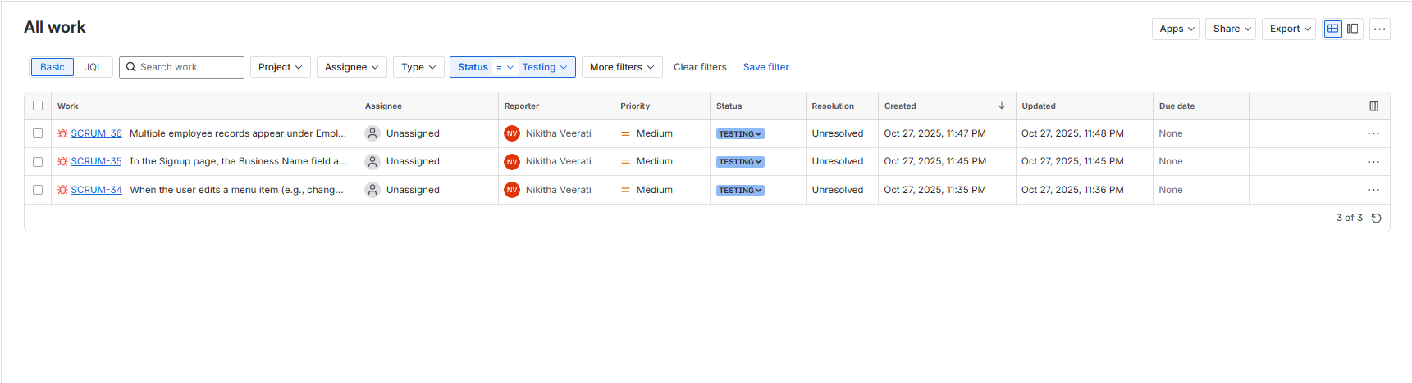

Bug details
SCRUM-34
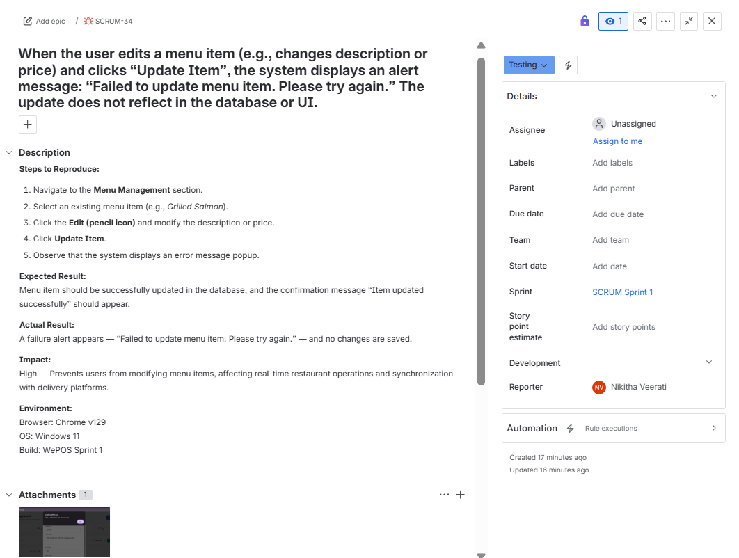
SCRUM-35
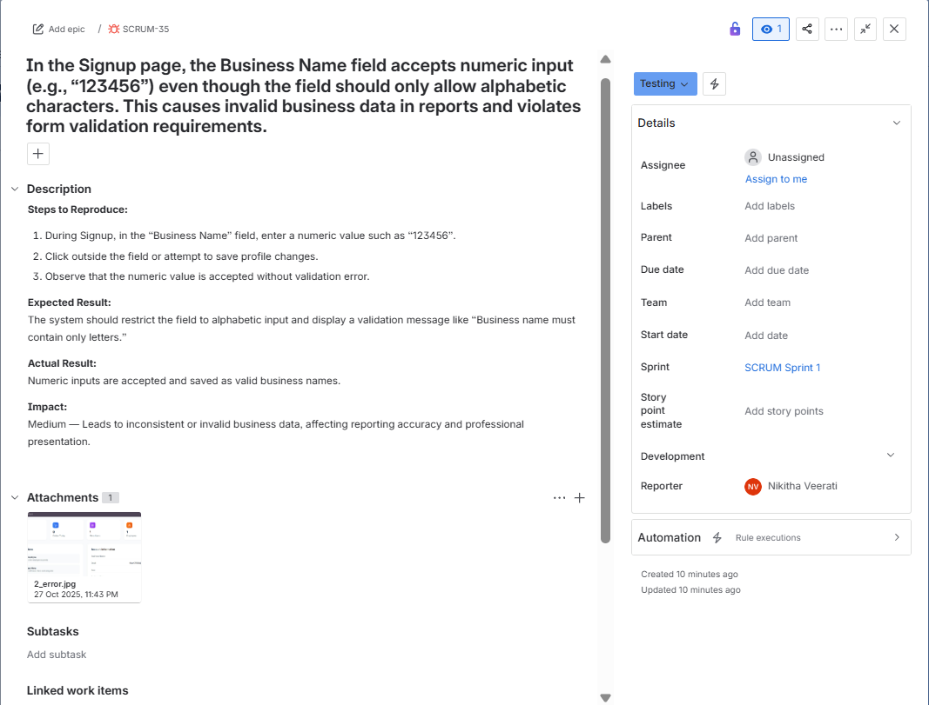

SCRUM-36
